**Pizza Sales – SQL Queries used and Results**

1. **Key Performance Indicators (KPIs) :**
2. **Total Revenue :**

select sum(total_price) as Total_Revenue from pizza_sales

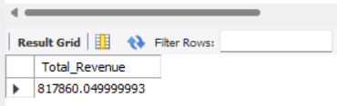

1. **Average Order Value :**

Average order value = $\frac{Total Revenue}{Total number of distinct orders}$ = $\frac{Sum(Total revenue)}{count(distinct order id)}$

select sum(total_price) / count(distinct order_id) as Average_order_value from pizza_sales

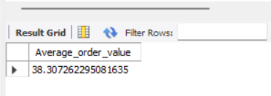

1. **Total number of pizzas sold :**

select sum(quantity) as total_pizzas_sold from pizza_sales

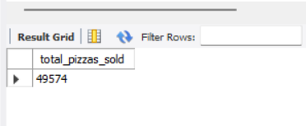

1. **Total orders placed :**

select count(distinct order_id) as Total_orders from pizza_sales

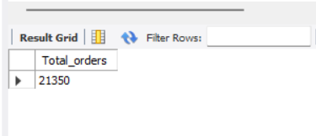

1. **Average pizzas per order :**

select cast(sum(quantity) / count(distinct order_id) as decimal(10,2)) as Avg_pizzas_per_order from pizza_sales

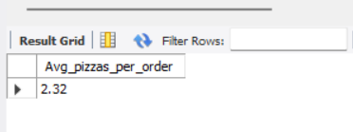

1. **Daily trend for total orders :**

select dayname(str_to_date(order_date,'%d-%m-%y')) as Order_day,

count(distinct order_id) as Total_orders

from pizza_sales

group by order_day

order by total_orders desc

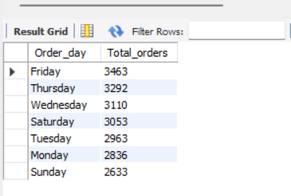

1. **Monthly trend for Total orders :**

select monthname(str_to_date(order_date, '%d-%m-%y')) as Month_Name,

count(distinct order_id) as Total_orders from pizza_sales

group by Month_Name

order by total_orders desc

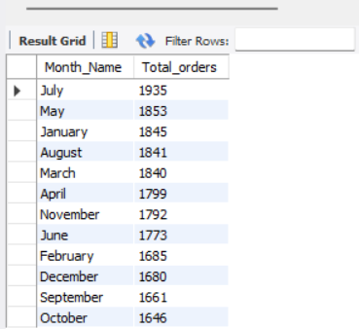

1. **Percentage of sales by pizza category :**

select pizza_category, cast(sum(total_price) * 100 / (select sum(total_price) from pizza_sales) as decimal(10,2))

as PTS from pizza_sales

group by pizza_category order by pts desc

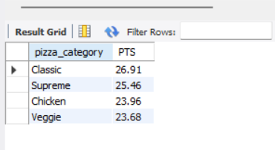

1. **Percentage of sales by pizza size :**

select pizza_size, cast(sum(total_price) * 100 / (select sum(total_price) from pizza_sales) as decimal(10,2))

as PTS from pizza_sales

group by pizza_size

order by pts desc

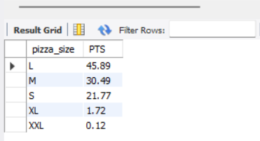

1. **Total pizzas sold by pizza category :**

select pizza_category, sum(quantity) as Quantity_sold_per_category from pizza_sales

group by pizza_category

order by sum(quantity) desc

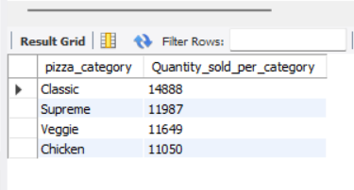

1. **Top 5 pizzas by Revenue :**

select pizza_name, sum(total_price) as total_revenue from pizza_sales

group by pizza_name

order by total_revenue desc limit 5

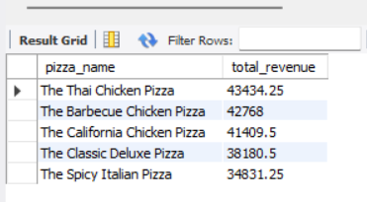

1. **Bottom 5 pizzas by Revenue :**

select pizza_name, sum(total_price) as total_revenue from pizza_sales

group by pizza_name

order by total_revenue limit 5

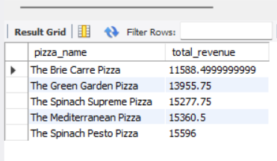

1. **Top 5 pizzas by Quantity ordered :**

select pizza_name, sum(quantity) as Total_Quantity from pizza_sales

group by pizza_name

order by total_quantity desc limit 5

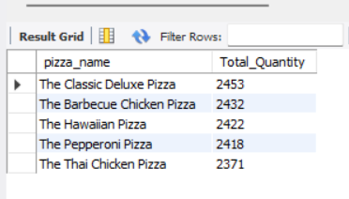

1. **Bottom 5 pizzas by Quantity ordered :**

select pizza_name, sum(quantity) as Total_Quantity from pizza_sales

group by pizza_name

order by total_quantity limit 5

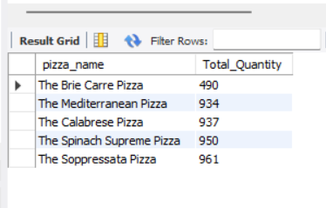

1. **Top 5 pizzas by Total orders :**

select pizza_name, count(distinct order_id) as Total_orders from pizza_sales

group by pizza_name

order by total_orders desc limit 5

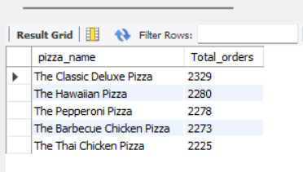

1. **Bottom 5 pizzas by Total orders :**

select pizza_name, count(distinct order_id) as Total_orders

from pizza_sales

group by pizza_name

order by total_orders limit 5

